QuPath Practical 3 – Combining Classifiers from other Projects

Learning Objective:
- Understand organisation of QuPath projects
- Develop strategies for training and classifiers and analysing projects

1. Copying classifiers
I have pancreas tissue sections stained with DAPI (DNA), Insulin (islets of Langerhans), and NeuN (neurons). I want to know how much the neurons overlap with islets.
To do this I have already made two projects which each contain a separate trained pixel classifier to segment Islets and Neurons, respectively (these are in the folders, “Islet Classifier Project”, and “Neuron Classifier Project”).
- Open the QuPath project within the “Islet Classifier Project” folder (“project.qpproj”)
  - Select the Project tab
  - Double click on the image thumbnail to open the image and its metadata
- The annotations used to make this classifier are in the annotations tab
  - These are useful, but you don’t want them to be part of your analysis
- Preview how the classifier would behave by going to Classifier >> Pixel Classifier >> Train Pixel Classifier
  - Choose “Load Training” and select this image
    - Note, you can load training from more than one image. This could be trained across a library of images
    - Training could also be done on a collage containing bits of multiple images
  - Choose “Live Prediction” to see its performance
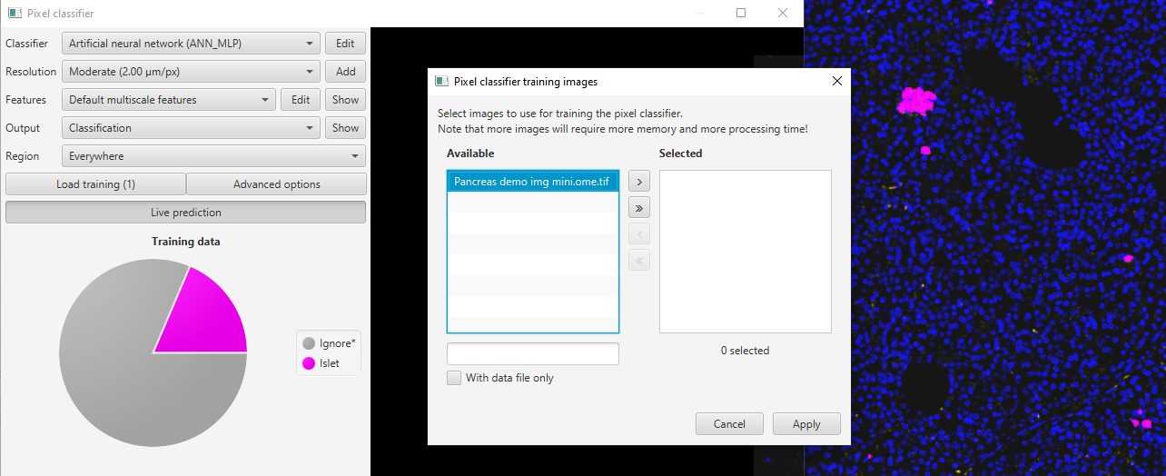
4
3
2
1
  - You could, at this stage continue to edit it. Don’t bother for this exercise

- We want a new project where we can combine this, and other models, to do some analysis
- Go to the file explorer and copy this entire folder (“Islet Classifier Project”), renaming it “Analysis Project”
  - This is now exactly the same
  - Look inside the folder: “Analysis Projects/classifiers/pixel classifiers”
  - You’ll see our islet classifier has already been saved previously
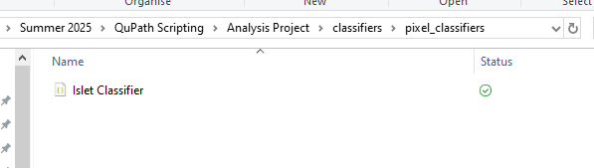
- Open another file explorer window
- Navigate into the “Neuron Classifier Project” in the “Practical 3” folder, to “Neuron Classifier Project/classifiers/pixel classifiers”
- Copy the “Neuron Classifier” and “Tissue Thresholder” into the classifiers folder of “Analysis Project”
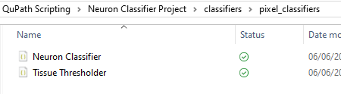
- Analysis Project should now contain all three classifiers:
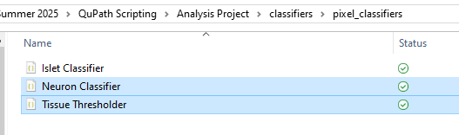

2. Using Pixel Classifiers

- In QuPath, open “project.qpproj” from within our “Analysis Project” folder
- This will still have all the annotations from model training. We don’t want those here, so select and delete them all, starting afresh.
  - Select all and press Delete
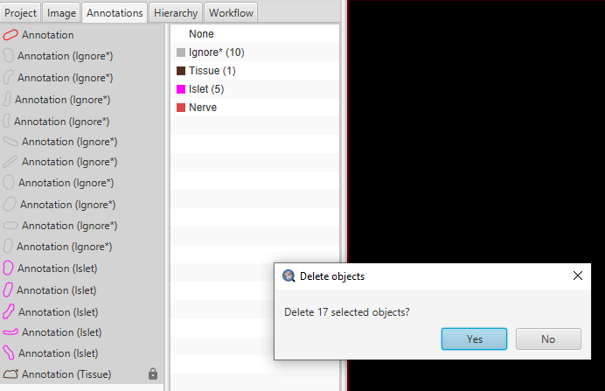
- Classify Tissue
  - Classify >> Pixel Classifier >> Load Pixel Classifier
    - Note that within here you’ll now see all three classifiers we’ve put into the project
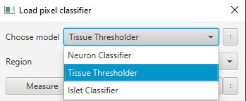
  - Select “Tissue Thresholder”
    - Region: “Everywhere” (this is just where the preview is shown)
  - “Create Objects”
    - Choose parent objects: “Full image”
  - Create Objects using the following parameters:

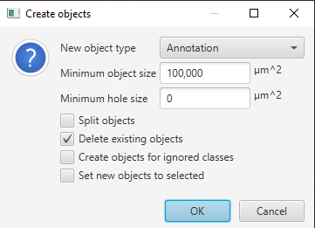
- We now have a “Tissue” annotation 😀
- Close the dialogue

- Classify Islets within the Tissue
- Classify >> Pixel Classifier >> Load Pixel Classifier
  - This time, select “Islet Classifier” and Region: “Everywhere”
  - Create Objects
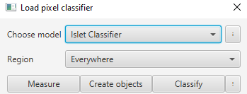
- This time we want the pixels to be classified only within the “Tissue”.
  - You can do this by selecting Choose parent annotation: “All annotations”, or by selecting the Tissue annotation and choosing “Current Selection”
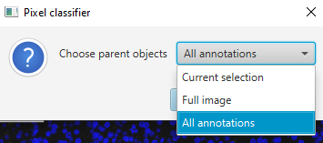

- Create objects with the settings below
  - Note that we’re splitting objects so each islet is a separate object

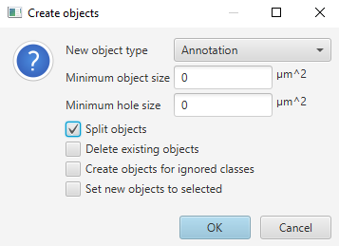

- Classify nerves within the Tissue
- Classify >> Pixel Classifier >> Load Pixel Classifier
  - This time, select “Neuron Classifier” and Region: “Everywhere”
  - Create Objects
- Again, we want to make annotations just within the Tissue. We can no longer choose it to run in “All annotations”, so we must select the Tissue in the Annotations tab, then set it to Choose parent objects: “Current selection”
  - We’ll make this automatic later
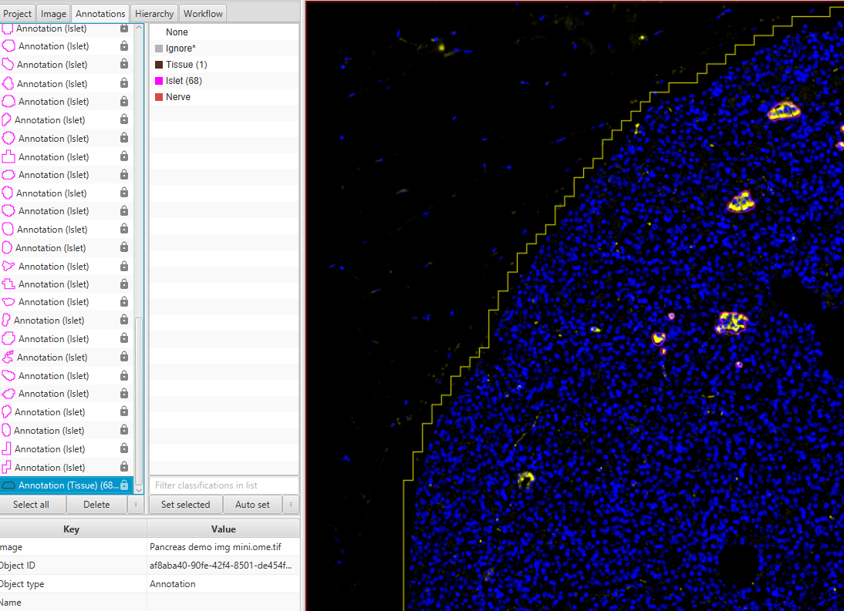
- Create objects using the settings below
  - Note that for the nerves we’re not splitting into separate objects
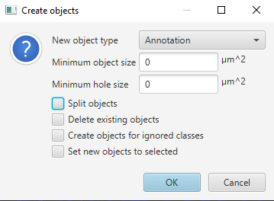
- You should now have a collection of annotations within your “Annotations” tab
  - One Tissue annotation
  - One Nerve annotation
  - Lots of Islet annotations

3. Creating a script
Finally, we’re going to make this into a script which could be run across a batch of images if necessary.
- Go to the “Workflow” tab
  - This has recorded most of your actions
- Press “Create workflow”
- Look through your recorded actions. There may be some extras which you don’t want to repeat, depending on how smoothly this demo has gone… What do we want to keep for a script? By selecting each command you can get an idea of what it’s done.
  - Right click and remove unwanted commands (could also go straight to the script editor and delete them)
  - We want to keep:
    - Reset selection
    - Pixel classifier create annotations (the Tissue thresholder)
    - Select objects by class
    - Pixel classifier create annotations (the Islet classifier)
    - Pixel classifier create annotations (the Neuron classifier)
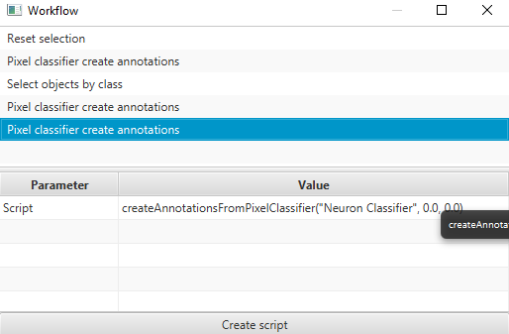
  - Create script

- Hopefully most of this looks fairly self-explanatory. Add some comments using “//” to help annotate the code
- Currently this code is almost ready to run on its own. The bit we need to automate, which was not recorded, is the selection of the Tissue annotation before running. You can use this line: selectObjectsByClassification("Tissue")
  - NB. If this line does not work, try re-writing it in your QuPath script editor. Sometimes characters are subtly altered during copy/pasting between programs
- Now try running the whole script
  - Save the script as “Segmentation Script”, this will save to the Scripts folder within your project
- The code should look like this (available for reference in the workshop material as “Practical 3 script”):
